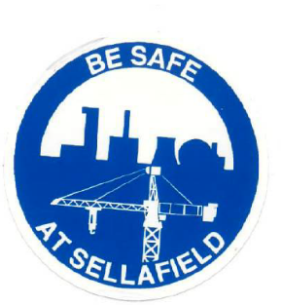
Sellafield Construction Health Safety & Welfare Committee

Constitution:
- Employer Reps Max 3
- Site Council Shop Stewards Max 3 (Comprise of NAECI & CIJC)
- Employer Safety Professional Max 1 (Comprise of NAECI & CIJC)
- Workplace Union H&S Reps, NAECI - 2, CIJC- 2, (Unite & GMB)
- SL Industrial relations Manager Max 1
- Site Convenor Max 1
- Major Projects Health & Safety professional Max 2
- Joint Chairs Max 2.
- Secretary Max 1 with a suitable deputy for absence
- Invitation only, soft services rep/guard force rep /guest speaker by request of the joint Chairs

Terms of Reference:
- Members: TU, NAECI, CIJC, SL, Major Projects, H&S professionals.
- Invitation: Soft Services, Guard Force request to the committee through the joint chairs.
- Review and discuss referrals from safety meetings across site.
- Identify safety and welfare issues across site, instigate best practice.
- Agree Monthly visits/inspections with committee members.
- Review Inspections, Track any outstanding actions.
- Review site accidents and investigations, share learning.
- Identify any learning and good practice, develop positive ways of working and share to help prevent accidents, injury ill health and contribute jointly to risk management.
- Potential provision to call urgent meetings to avoid industrial action.
- Review new documentation, legal, MCOCL, Major Projects.
- Review effectiveness of the committee (6 month)

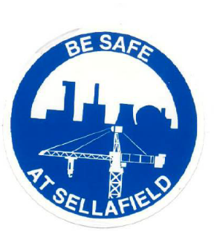
Sellafield Construction Health Safety & Welfare Committee

AGENDA

- Welcome
- Apologies/introductions.
- Chairs Comments/Safety Share.
- Review minutes/Acceptance/Actions Review.
- Correspondence issues/emails to committee members.
- Discuss issues from Health & Safety meetings across site.
(any with a potential to go procedural?).
- Inspections review/agree, identify any welfare issues across site.
- Review site Investigations/accidents, incidents.
- Discuss/review any new legislation/ documents.
- Major Projects updates James & Claire.
- Management of contractors/Industrial relations officer report.
- Good practice/OEF learning to discuss/share.
- Wellbeing, Mental and Physical Health & Charity donations/nominations.
- AOB



Sellafield Construction Health Safety & Welfare Committee

Protocols for Urgent HS&W issues
The requirement to convene an emergency meeting of the Sellafield HS&W Committee due to a potential emerging issue on site, the following expectations are to be followed
- Committee members to be part of Watts App group solely for purpose of urgent protocols only.
- Contact as many of the Committee members as possible.
- Call a meeting within 1 hour of the emerging issue.
- Discuss the issue with local management and if necessary, agree a set of actions/agree any timescales to resolve/ de-escalate the issue/s, and monitor.
- No unprocedural/industrial action should take place, and the protocols are to be followed with all parties committing to utilise the procedures.
- Remind All Parties that if the unprocedural/industrial action occurs then the subcommittee will not be able to convene and progress the issue/s to an amicable conclusion.
- Once actions/outcomes and timescales for resolution have been agreed and the Committee are monitoring no Industrial/unprocedural action is to occur.
- If the Committee and local management cannot agree actions/outcomes, then the issue should be put into procedure and in the interim no industrial action should occur.

